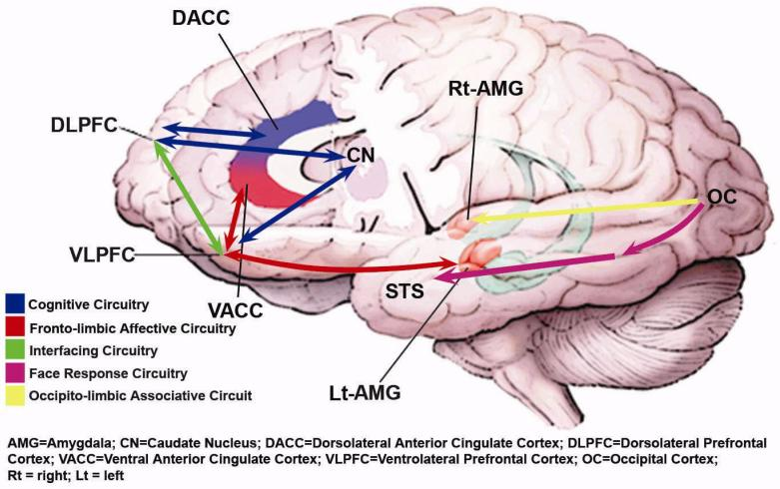
Functional Brain Circuits in Pediatric Bipolar Disorder
Cognitive Circuitry shows the key link between the DLPFC and the caudate involved in attentional control, and the connection between the VLPFC and the caudate/ventral striatum implicated in response inhibition and attention. Frontolimbic Affective Circuitry spanning from the VLPFC to amygdala participates in top-down regulation of emotion. Interfacing Circuitry illustrates the functional connectivity between cognitive regions (DLPFC and DACC) and affective regions (VLPFC and VACC/pregenual and subgenual ACC) at the level of PFC and the intermediary ACC; working in concert in healthy individuals. Face Response Circuitry connects the visual or occipital cortex with fusiform gyrus (not shown here) and the STS. The Occipito-limbic Associative Circuitry connects the occipital cortex to right amygdala, involved in fast or automatic processing of emotional/facial stimuli.

